JEFFREY A. CARMEN, Ph.D. LICENSED PSYCHOLOGIST
BIOFEEDBACK, BEHAVIOR THERAPY, PSYCHOTHERAPY 4016 Henneberry Road, Manlius, New York 13104-9567
migraines, tension headaches, pain disorders, impulse control disorders
stress management for chronic diseases PHONE: (315) 682-5272
augmentative communication and control systems FAX: (315) 682-4716
biofeedback and physiological data systems carmen5272@aol.com

PASSIVE INFRARED HEMOENCEPHALOGRAPHY, 4 YEARS AND 100 MIGRAINES

ABSTRACT.
Background. 100 migraine sufferers were treated using Passive Infrared Hemoencephalography (pIR HEG) over a period of four years. All subjects met the criteria for at least one of the categories set forth in the International Headache Society (IHS) classification criteria for headache disorders (IHS, 1988) for primary migraine.
Methods. Subjects were treated using the pIR HEG system in 30 minute sessions. A central forehead placement (approximately Fpz) was used for the sensor assembly for all subjects. Changes in headache patterns were examined. In addition, after two years, an infrared video imaging system was added to the data collection process. This was available for 61of the 100 subjects. Infrared forehead images were captured at the start and end of each session to examine changes in prefrontal cortical brain activity.
Results. Most of the subjects improved control over their migraine headaches. Over 90% of those subjects who completed at least 6 sessions, reported significant improvements in migraine activity.
Conclusions. pIR HEG appears to have a strong impact on migraine headaches, even for people who have not had a positive response to medication. Headache response by the end of 6 sessions appears to be a good predictor of probability of improvement.

KEYWORDS. pIR HEG, HEG, Hemoencephalography, migraine, headache, biofeedback, neurofeedback, frontal, inhibition.

Carmen, J. A. (2004), Passive Infrared Hemoencephalography: Four Years and 100 Migraines.
Journal of Neurotherapy, 8 (3), 23-51.

BACKGROUND
Introduction to pIR HEG.
The term Hemoencephalography was first used by Hershel Toomim in 1997 (Toomim, 2002) to describe his process of Near Infrared Spectrophotometry (NIRS HEG) system. The Passive Infrared Hemoencephalography (pIR HEG) system evolved from Carmen’s application of infrared technology to peripheral thermal biofeedback (Carmen, 2002). The evolution was in part, based on the psychophysiological concepts developed by Toomim (Toomim & Carmen, 1999) with his NIRS HEG system.
Both systems (pIR HEG and NIRS HEG) respond to blood flow dynamics as a source of data. They also share a total freedom from eye roll and surface EMG artifacts. This makes both systems well suited for exercising brain activity in the prefrontal cortex, without any concern for the effects of these artifacts on the integrity of the acquired signal.
The pIR HEG system was specifically developed as a potential intervention technique for migraine headaches. As such, most of the developing data regarding efficacy relates to migraine headaches. The conceptualization for training cerebrovascular control to produce migraine control was based on the tentative assumption that if a person could learn to control cerebrovascular activity, especially control over excessive vasodilation, control over migraine activity would follow.
Unfortunately, training a person to directly constrict excessively dilated cerebrovascular structures did not work, regardless of whether a person had a migraine headache at the time or not. Most people could easily learn to increase the pIR HEG signal, but few could reduce it at all.
The hypothesis that reducing excessive vasodilation in the cerebrovascular system would reduce migraine pain was based on the vascular theory of migraine pathophysiology that was popular at that time (Diamond, 1994). Migraine researchers have since rejected that theory in favor of a more comprehensive theory of migraine pathophysiology involving the trigeminal nerve and its interactions with the brainstem and cerebrovascular system (Goadsby, 2001). This may be an interesting example of an intervention process that failed to work as anticipated because it was conceptually based on a theory that was later invalidated.
Based on Toomim’s pioneering application of NIRS HEG to the prefrontal cortex (Toomim & Carmen, 1999) to increase brain activity, the pIR HEG process was modified to train increases instead of decreases. This turned out to be a very good idea. When the pIR HEG sensor assembly was placed at Fpz, and the training process was directed towards increasing prefrontal cortical brain activity, the effects were direct and positive on both migraine prophylaxis and actual abortion of migraine headaches. This effect on migraine activity may have more to do with training control over the inhibitory effects of the prefrontal cortex than training direct vascular control. The effects are also more consistent with current thinking regarding the pathophysiology of migraine (Goadsby, 2001).
The nature of migraine.
The true nature of migraine headaches remains elusive. Migraines represent a complex paroxysmal neurovascular phenomenon. They occur in two major stages, although some researchers have postulated three and four stages.
The first stage represents a steady state of readiness to have the headache and is sometimes associated with unusual neurological and neuropsychological phenomenon, but no headache. Some of the best descriptions of this stage of migraine activity can be found throughout Oliver Sacks’ book “Migraine” (Sacks, 1992).
The second stage is the headache. This often occurs on sudden relief from a prolonged period of psychological or physiological stress (Diamond, 1994). The fact that the second stage of a migraine correlates with excessive dilation of cerebrovascular structures was one of the pieces of data that caused migraine researchers to erroneously hypothesize a cerebrovascular pathophysiological mechanism. The excessive vasodilation appears to be a migraine effect rather than cause. It probably participates in pain generation rather than originates the pain (Goadsby, 2001).
Within the field of headache research, the standard for headache classification is still the International Headache Society (IHS) manual (Headache Classification Committee of the International Headache Society, 1988). The classification categories set forth in this manual represented an attempt to stabilize headache categories for the purpose of communicating research findings.
These classification categories were set forth at a time when the understanding of the pathophysiology of migraine was less clear than it is currently. Now that migraines have been subjected to sophisticated imaging techniques such as fMRI and PET, the precise pathophysiology is still unclear, although it is more clear now than when the IHS classification system was developed.
The theory of migraine pathophysiology that currently has the most support among migraine researchers is that migraine is involved with and possibly caused by paroxysmal activity of the trigeminovascular system (Goadsby, 2001). This system includes all branches of the trigeminal nerve, the entire cerebrovascular system, as well as the brainstem.
It is even unclear as to whether or not primary migraine (that which is not caused by head trauma or disease) represents pathology at all. Most physiologically based behaviors and internal mechanisms that permeate the entire human race probably have their origins in evolutionary variables (Pinker, 1997). Loader (2002) suggested that the migraine-prone nervous system might have had a variety of reproductive survival advantages such as causing a reactive compensation to environmental conditions that produced global brain hypoperfusion, or alternatively producing a learned avoidance of external environmental conditions such as ingestion of toxic plants that would trigger migraine headaches. In a similar manner Carmen (2002) hypothesized that the tendency of migraine sufferers to trigger a headache as a direct correlate of the sudden drop in barometric pressure of an approaching storm may once have correlated with a reproductive survival advantage by serving as an early warning system to seek shelter.

Hypothesized mechanisms for the effects of pIR HEG on migraine.
The positive effects on migraine management after exposure to the pIR HEG system when the sensor assembly is placed in the center of the forehead, behave in a manner consistent with a global increase in the amount of control generated by the inhibitory and regulatory functions of the prefrontal cortex (Goldberg, 2001). Using an electronic circuit analogy, this would be equivalent to increasing the gain of the negative feedback loop in which a portion of an output signal is fed back to the input to reduce the output. Negative feedback circuits are inherently stable. (Madhu, 1985)
This inhibitory hypothesis is based in part on the following observations:
- Patients being treated for migraine headaches using pIR HEG consistently report spontaneous changes in attending behavior in the direction of easier and smoother sustained attention to tasks. Correlated with this is a reduced distractibility to both internal and external stimuli.
- Patients being treated for migraine headaches using pIR HEG consistently report spontaneous changes in emotional reactivity in the direction of emotional responses that are less rapid and less strong in response to stimuli that don’t call for a rapid and strong emotional response.
- pIR HEG requires a significant amount cognitive “effort”; a concept first clearly defined by Pribram & McGuinness (1975). Sometimes during the first session or two this sustained effort appears to produce the functional equivalent of prefrontal cortical fatigue. When this happens, the behavioral effects appear to be those of disinhibition (difficulty attending to task, rage reactions, severe migraine activity) for the rest of the day. Typically on the following day after a good night’s sleep, inhibitory functions are normal or better than normal for that person, suggesting some sort of an exercise/ rest/recovery mechanism.

METHODS
General.
This is a collection of cases not a controlled study. The results must be viewed within that context. The setting was a clinical setting rather than a research setting. Also, pIR HEG was not the only intervention variable. At each session, attempts were made to maximize migraine management effects beyond just using the pIR HEG system. These additional variables included but were not limited to the following:
- Discussion of eating patterns and food triggers.
- Discussion of stress response patterns.
- Discussion of less obvious potential triggers such as the driving effects of visual flicker sources.
- Behavioral methods of migraine management.
- Behavioral and insight oriented psychotherapy as needed.
These additional interventions represent a potential source of contamination in terms of isolating effects to the application of pIR HEG. However, there is one built-in control over the effects of these additional interventions. They are the same additional interventions that were used with the biofeedback based migraine intervention techniques previously used by Carmen that were considerably less effective than pIR HEG (Carmen, 2002).

Subjects.
This population represents a heterogeneous group of 100 patients who participated in migraine treatment using the pIR HEG system. There was only one selection criteria applied. All patients met the criteria for at least one of the migraine categories set forth in the IHS classification criteria for headache disorders for primary migraine headaches (IHS, 1988). Patients whose migraines were secondary to head injury or an active disease process were excluded.
Typically patients were referred by a neurologist or primary care physician, due to one of three reasons:
- Poor response to medication.
- Concerns about the potential negative effects of medication, including the risk of fetal effects during pregnancy as well as potential health risks directly to the migraine patient.
- Concerns about addiction to migraine medications.
In most cases migraine medications represent an acceptable risk/benefit ratio. However, there is one uniquely serious risk category. The “triptans” that represent the current standard of care for aborting migraines have been documented to constrict coronary arteries and occasionally produce death through this mechanism (Tepper, 2001). Anyone who has coronary risk factors or active coronary disease is generally prohibited from using these drugs. For these people, behavioral treatments may represent a medical necessity rather than optional choice.

Procedure variables.
Real world environments are not as well controlled as research environments. For these 100 patients, length of active work with the pIR HEG system was generally limited to 30 minutes within each office visit, but was sometimes less than 30 minutes if fatigue, increase in headache, or fading attention made continuing difficult. Sessions were usually scheduled once per week, although sometimes sessions were less frequent due to scheduling conflicts. Sessions were eventually spread out to weeks and months between sessions, based on how long the patient was maintaining migraine management. Morning was given preference for time of day, but the actual time of the sessions was also determined by personal variables such as school and work schedules. The total number of sessions was determined by patient preference. Often the response of the headache to the pIR HEG sessions was rapid but not complete, and patients would elect to continue sessions, progressively increasing the number of days between sessions, to fine tune the migraine management. Other times, significant improvement was considered sufficient, leaving the remaining headaches to be managed with medication or simply tolerated. Sometimes more sessions were scheduled to work on other aspects of self management, even though the migraines were under stable regulation.

Basic descriptive data.
Table #1 provides a breakdown of the sex and age of 100 subjects. This reflects the relatively higher ratio of females to males in the general population who suffer from migraines (Marcus, 1999). The female to male ratio in this study is approximately 2:1, which is similar to the ratio of 3:1 reported by Lipton et. al. (2001). The ages of the 100 subjects are somewhat younger than the general population suffering from migraines (Lipton et. al. 2001). The slight differences in age and sex between these 100 subjects and the general population probably reflect the age and reason people in this geographical region seek treatment (or are referred for treatment).

TABLE 1
 | MALE | FEMALE | BOTH
NUMBER OF SUBJECTS | 36 | 64 | 100
YOUNGEST | 8.21 | 11.00 | 8.21
OLDEST | 67.31 | 58.49 | 67.31
MEAN AGE | 16.73 | 27.95 | 23.91

Instrumentation.
The pIR HEG system began to be used clinically in September, 1998 (Carmen, 2002). The system captures infrared radiation, within the 7 to 14 micron band, with a center weighted circular field of view of 32mm. The thermal resolution is .01 represented in the equivalent of degrees Fahrenheit. Based on the physics of thermal transmission (Fraden, 1996), the best estimate of the area of the brain to which the system is most sensitive would approximate the size and shape of a golf ball, directly under the center of the field of view of the sensor assembly. The sensor assembly for the pIR HEG system is mounted on the forehead, recording infrared light waves emitted from the forehead in much the same way that a camera records visible light waves reflected from objects.
The thermal activity picked up by the pIR HEG system reflects excess thermal energy generated by the brain as a function of brain activity. Increases in the pIR HEG signal reflect a composite of thermal energy generated by brain cells, vascular supply and vascular return, although there is disagreement among researchers as to which source represents the largest thermal contribution to the increase. Some researchers have hypothesized that the major contribution of the thermal increase comes from brain cells (Kiyaikin, 2002). Others have hypothesized that it comes mostly from the vascular system, (Swerdlow and Dieter, 1991). Shevelev (1992) is more supportive of the composite hypothesis.
Regardless of the source, it seems reasonable to view the pIR HEG signal as a thermal waste product of increased brain activity (Carmen, 2002). Whereas the relative magnitude of source contributions to the pIR HEG signal remains an unresolved issue, the only thing that is of immediate importance to treatment issues is that increases in the pIR HEG signal are localized and follow increases in localized brain activity.
A second type of equipment was also used, but for data collection only rather than as a feedback source. This equipment was not used with all patients because it was only available for the last two of the fours years. This additional equipment is not part of the pIR HEG system, but is used as a means of monitoring the effects of training. It is an infrared video capture system that captures changes in infrared patterns as thermal energy is emitted from the forehead as a function of focal changes in brain activity.
Infrared image capture systems.
The initial system was a STARSIGHT model 80 camera manufactured by Insight Vision Systems (Malvern, England). This camera failed after one year of use, and since it is no longer being manufactured, repair parts were not available. It used older technology and had relatively poor image quality. The thermal resolving power was too unstable to accurately specify.
The STARSIGHT was replaced with a Raytheon 2000b digital core (Raytheon Corporation, Dallas, Texas), modified for the capture of infrared images of the head. The thermal resolution of this system is .04 degrees Fahrenheit equivalent.
Both systems are similar in some respects. They both match the 7 to 14 micron spectral range of the pIR HEG system. What they “see” corresponds to the data captured by the pIR HEG system. They both use a 50mm, f1.0 lens, and have a pixel resolution of 240x320. However the electronic processing of the signal is so different between the STARSIGHT and the Raytheon camera systems that the images captured are not directly comparable.
For both systems, image capture from the camera to the Windows 2000 based computer was carried out using an Integral Technologies FP3D industrial frame grabber using the Integral Technologies software designed for that particular hardware (Integral Technologies, Indianapolis, Indiana).
Part of the pIR HEG process involves watching a video, the operation of which is regulated by a threshold setting on the pIR HEG system. The VCR used was a Hitachi FX6404, displayed on a standard 20 inch JVC television, viewed at a distance of 8 feet.
Additional Specifications.
The sensor assembly for the pIR HEG system has a response speed of 80 milliseconds. Response speed is defined by the industry standard definition of the time required to reach 67% of the full value of the object being measured (Fraden, 1996). The sensor assembly picks up the infrared radiation from the surface of the forehead as blackbody radiation and then converts the infrared signal into a dc signal that is fed to the input of the pIR HEG computer. The signal is then processed and converted to a green digital LED display. Each LED is .56 inch in height. The data sampling rate is 60 times per second. The display update rate is 3.5 times per second. The display presents the data as a temperature equivalent in degrees Fahrenheit with a resolution of .01 degree. There are no electrodes used, so there is no direct electrical contact with the patient. The system also interfaces with a universal remote control that provides threshold based control over external audiovisual sources such as a VCR or DVD. A threshold is set on the internal computer, above which a movie will turn on, and below which the same movie will turn off.
61 of the 100 subjects were also monitored with one of two of the infrared image capture systems previously described.

Procedure.
For those subjects who began treatment after the installation of the infrared video system, an image capture was carried out before and after each session. A baseline image was captured and stored in digital tiff format. At the end of the session a second image was captured. Images were captured using the 50 mm lens set at f1.0, at a distance of 3 feet from the subject. With the Raytheon system, the maximum thermal capture range was set in software at a 10 degree Fahrenheit equivalent.
In the next step, the sensor assembly was placed on the forehead so that the center of the field of view was in the center of the forehead, roughly at Fpz. (See figure 1). It was held in place with soft hook and loop straps just tightly enough to prevent slippage. Since the sensor assembly acquires light wave infrared data, direct physical contact with the forehead is only necessary to the extent that it prevents movement of the sensor assembly.
Image #1 is an infrared image of the author wearing the sensor assembly on his forehead, captured with the Raytheon camera. Please note two significant things. First, infrared by definition has no color. All of the infrared images in this article have been digitally converted from grayscale images (the native format for infrared cameras) to something called “false color” (Kaplan, 1999). In this case the colors assigned to intensity changes range from black (lowest intensity) to red to yellow to white (highest intensity). This color code was selected for its intuitive value, since it is the pattern seen on stove burners and other heated objects and is easy for people to comprehend the meaning of these colors. Second, all images (except the one of the author) have been captured with eye glasses removed. Both glass and plastic eyeglasses are opaque to this part of the infrared spectrum, resulting in a total loss of infrared data from that portion of the face covered by the glasses. Glasses were left in place in this picture to demonstrate that mechanism.

IMAGE 1
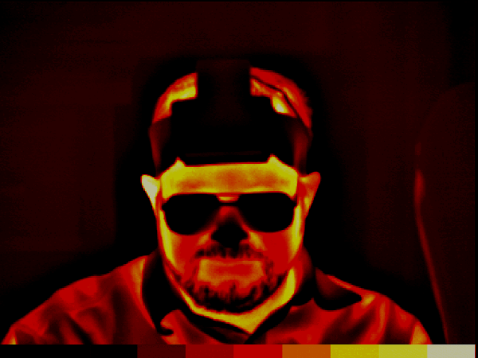

Typically for migraine, the center of the forehead is the only location used. With humans this is a unique location. The human forehead is devoid of hair, making it an ideal location for the radiation of excess thermal energy from the brain. It also makes it an ideal location for recording thermal activity from the prefrontal cortex.
After the baseline infrared image was captured, the sensor assembly was placed on the forehead and the pIR HEG display turned on. At the same time, a movie (selected by the subject) was started. After several minutes a threshold was set above the current display reading, causing the VCR to place the movie on “pause”. This required the subject to increase the pIR HEG signal to a point in excess of the threshold setting in order to turn the movie back on.
The mental state that produces the maximum output of infrared radiation from the forehead is a simultaneous combination of the following:
- Very low levels of discomfort such as anxiety, anger, or frustration.
- Very intense levels of sustained concentration.
This is an affective/cognitive combination that usually does not feel familiar or intuitive. However most were able to learn the concept within a minute or two.

Headache measures.
Most, if not all headache research also includes some sort of pain index. A review of the last 5 years of the IHS journal, Cephalalgia revealed various pain scales from 0 to 3, all the way up to 0 to 100. Some researchers also used faces that smile or frown as a correlated measure of pain. The commonality of these measures among all the studies is that the lowest number or face represents no pain and the highest number or face represents the worst pain the person can imagine. There is however a problem with all of these measures. When headaches start to improve, people forget how bad the headaches used to be. Without realizing it, they start to assign higher numbers to headaches of pain levels to which they used to assign lower numbers.
All of the subjects included in this study rated their headaches on a 0 to 10 scale. However, the only consistently reliable number was “0”. Regardless of the rating system used, total lack of pain is a stable, universal concept.
An additional, and probably more stable migraine change measure is the point at which the person reports having a headache, but is no longer able to tell whether it was a migraine or not. That was the primary head pain change measure used in this study to measure “significant improvement”.
It is a concept that at face value appears vague, but has turned out to be one of the more robust measures, at least for the people in this study. For people who are still getting some headaches, this is a more useful measure than “no pain” because it reflects the point at which the headaches are discernable but not troublesome. Although it does not have a numeric intensity equivalent, it appears to be a more reliable and valid measure. It also allows a frequency measure to continue as an added headache variable.
For the purpose of this study, “significant improvement” has been functionally defined as that point at which the subject was still getting some headaches but was unable to clearly identify them as migraine because the pain level was so much less.
Infrared imaging provided a different type of measure. Although it reliably displayed patterns of thermal energy emitted through the forehead, for many of the subjects the migraine itself was visible. During a migraine headache, the painful areas of the head were often visible as high output areas on the infrared image. Although the meaning of this is not entirely clear in terms of the underlying pathophysiological mechanisms, the correlation with pain and location is very high. Typically subjects who viewed the image would spontaneously say something like “that’s exactly where it hurts”. The intensity of this image reliably decreased by the end of the session, even though the output of the forehead region increased. In addition, the amount of the reduction of the intensity of the headache area correlated with the pain reduction by the end of the session.

SAMPLE CASES
Color code. The following cases were drawn from those for whom infrared images were available. The images follow a color code of thermal output ranging from black (least thermal output) to red to yellow to white (most thermal output). Migraine activity is generally correlated with yellow, and sometimes white. The reference color bar is inserted below as image #2. Each bar in this image reflects a 1.0 degree Fahrenheit equivalent. Actual captured images display a minimum resolvable temperature difference (MRTD) (Kaplan, 1999) that is much more sensitive, by blending colors and intensities.

IMAGE 2


Patient #90.
This was a 15 year old male, referred for 4 years of headache activity that had evolved into chronic migraine activity of variable pain level for the previous 6 months. There was no identified disease process associated with the headache activity. He had a strong family history for migraines. That combined with the family history suggested a familial/genetic etiology. He had been on a variety of prophylactic medications but they were having minimal to no effect. Abortive prescription and over the counter (OTC) medications had been taken as often as daily. There were no identifiable environmental triggers. He was an excellent student but not attending school when first entered treatment due to the headache activity. He would wake with a mild to moderate headache daily, 7 days per week, including vacations. Migraines that are active 7 days a week and on vacations tend to be especially stubborn. His headaches would usually become gradually worse by afternoon and get somewhat better after abortive medication. The location of the headaches was unstable, sometimes focal and sometimes generalized throughout the whole head. Appointments were scheduled for mornings when headache activity was at the lowest level, because high pain levels made concentration difficult. Parts of his face are “grayed out” in these images to help preserve anonymity.
Even after the first session, the low level headache that he came in with was gone by the end of the session. Initially, the relief obtained was temporary and did not last more than one day. As the sessions progressed, the headache control lasted progressively longer.
On session #5 he came in with a severe left sided posterior migraine that he rated as a “10” on a 0 to 10 pain scale. The baseline infrared image (IMAGE #3) is inserted here.

IMAGE 3
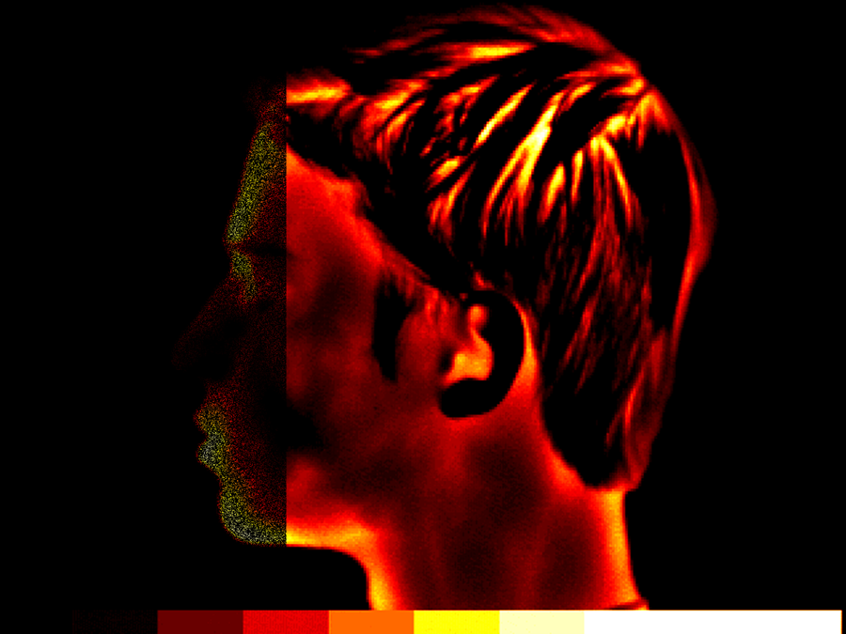

After a 30 minute session of pIR HEG, the pain level dropped to “3 or 4” pain level. That image (IMAGE #4) is inserted here.
IMAGE 4
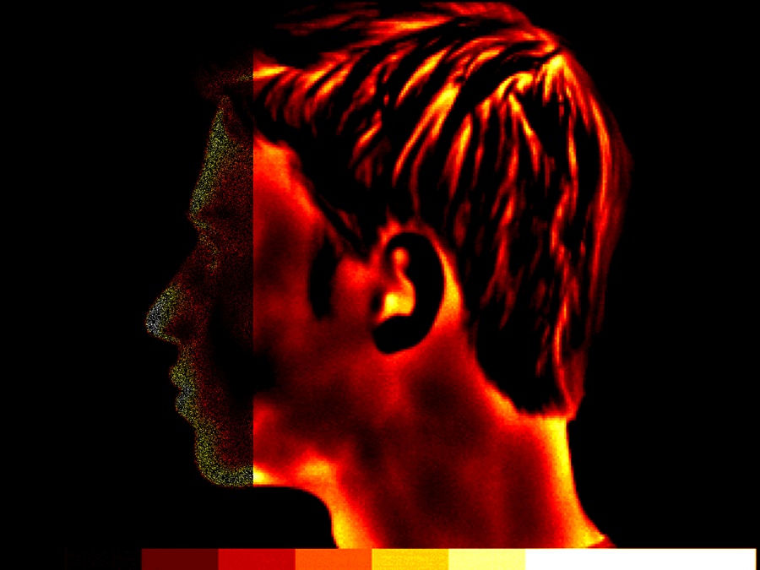

IMAGE 4 shows a post session lower intensity of thermal output in the left posterior region of his head, corresponding to a reduced level of pain. Both pre and post images delineated almost exactly the area of his head pain.
On session #10 he came in with the same headache in the same location but the pain level was so low that the actual level was very difficult to determine. This is an example of the type of change that is considered “significant improvement”. He could feel it, but not strongly. He rated it as a “1”. That image is inserted here as IMAGE #5. Note, hair interferes with infrared transmission in these frequencies. The yellow mark in the back of his head is where the hair is parted and does not represent pathological signal intensity.

IMAGE 5
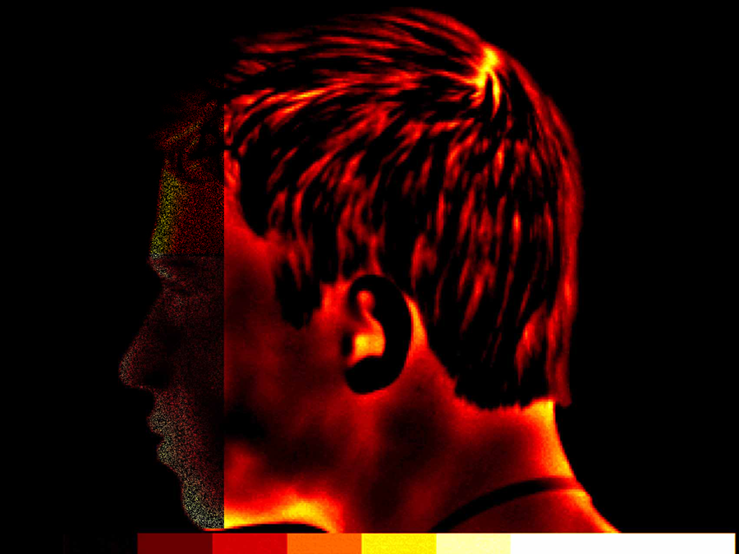

By session #12 the headache activity was no longer chronic, all medications were discontinued, and he was back in school. Sessions were stretched to one every 3 weeks. By session #17 he was still getting occasional mild headaches, lasting an average of 30 minutes. He was no longer using abortive or prophylactic medication, and headaches were no longer interfering with his life.
Comments: This case used more sessions than most, but may have had elements of rebounding from excessive medication use. It is not typical to be able to image migraines as precisely as these, which is one reason for the inclusion of this particular case.

Patient #3.
This was an 11 year old pre-pubescent female who had been getting focal and generalized migraines for the previous two years. They varied from daily to weekly, usually towards the end of the day. There was no identified disease process associated with the headache activity. Everyone in the immediate family had migraines, making a familial/genetic etiology a high probability. The only medications used were OTC analgesics and then only for the very severe headaches. She responded very rapidly. By the 6th session she was under complete control with no headaches. At a two month follow-up there were no further headaches.
Comments: Migraines often start up in girls as adolescent hormones start to kick in, and it is not unusual for the migraines to begin prior to the onset of first menstruation. One to two years prior is somewhat typical. Often as adolescence progresses, the migraines get worse. In this case it is too early to tell whether they are just completely gone, or if she will be back in another year or two with another bout of severe headaches. In any case, based on experience with others, if she does have a recurrence, it will probably take less work than the first time to bring them back under control.
Image #6 is her first session baseline without headache present. The relatively dark frontal image suggests relatively low overall prefrontal brain activity. Experience suggests that this can be either part of the problem in terms of allowing the brainstem migraine generator to be too active, or it could be a product of being in pain much of the time.

IMAGE 6
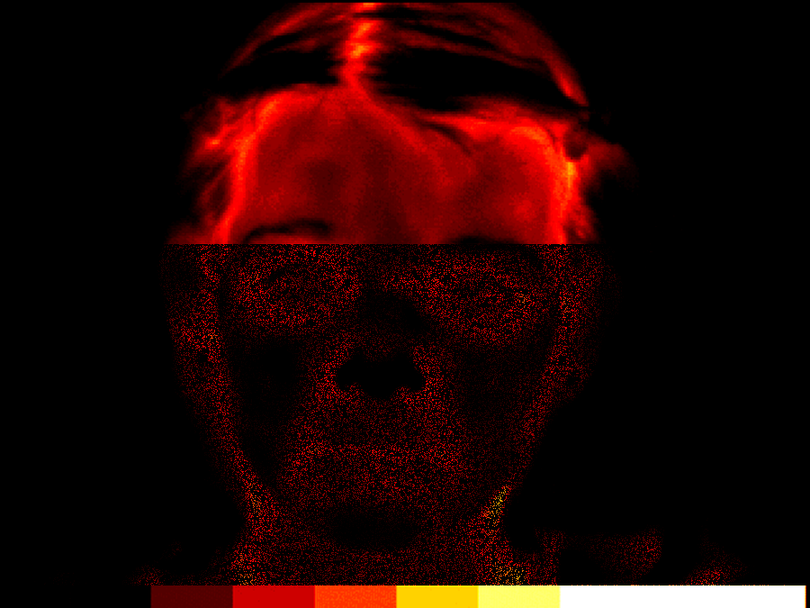

Image #7 is the baseline image from the second session. She came in with a left frontal migraine, which imaged nicely in yellow around the area of the left temporal artery, which is the area to which the migraine was localized. This does not mean that the migraine was being generated by the left temporal artery, although it might have been. That still represents a theoretical issue.

IMAGE 7
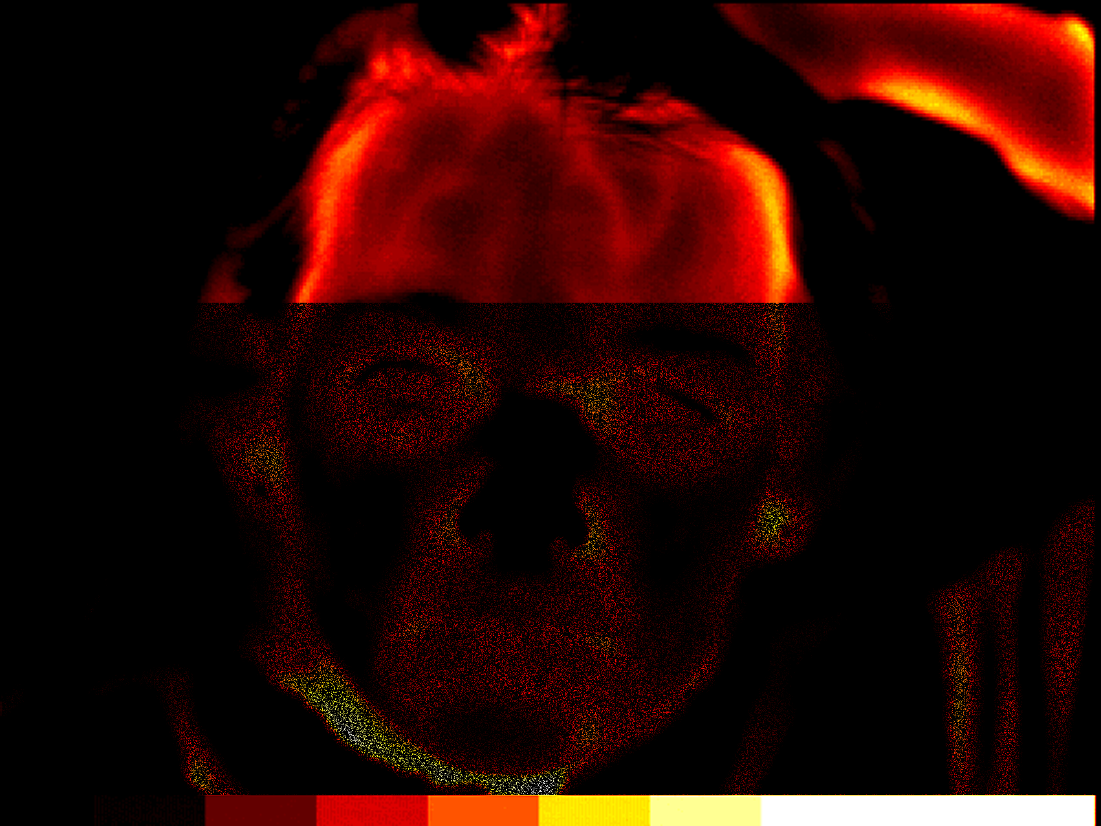

Image #8 is the post session image from the same session. The migraine is not completely gone, but down from severe to mild (“8” down to “3” by her rating). Note that the right and left sides of the forehead are reasonably balanced in terms of thermal output, and that the dark areas of the forehead are less dark. In many patients, the dark areas appear to take on meaning in terms of focal brain activity deficits and tend to correlate with emotions and attentional patterns. However as a general guideline, when the dark areas become lighter, people feel better physically and mentally.

IMAGE 8
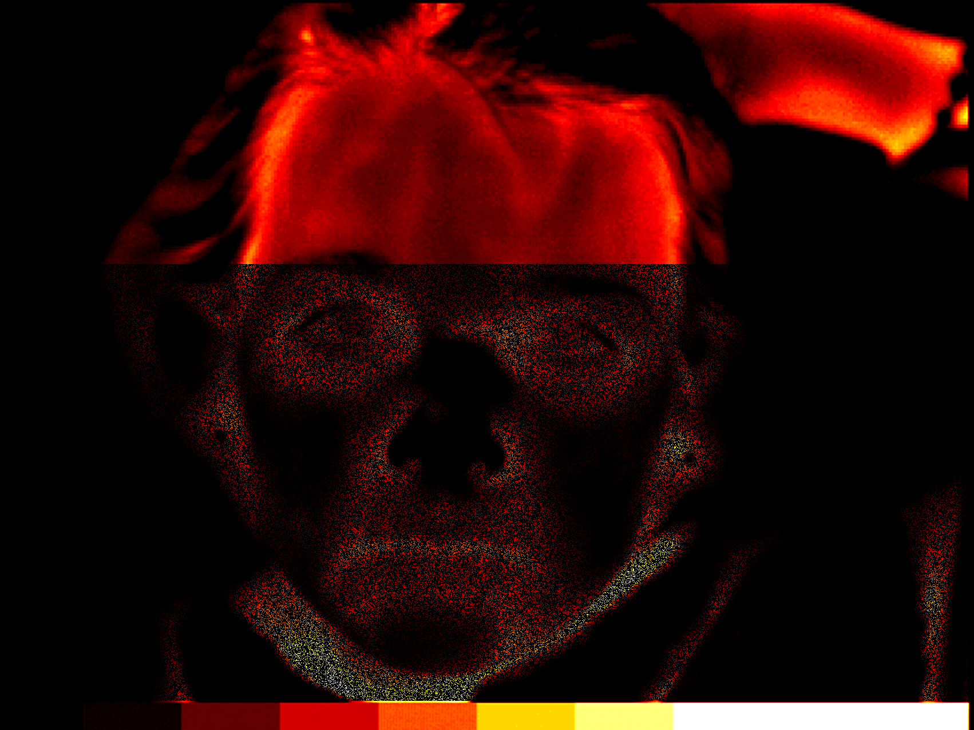

Image #9 is the baseline image from the final (6th) session. This is significantly lighter in the forehead region, indicating greater prefrontal brain activity. There was no headache present and no further headaches were reported on 1 and 2 month follow-up.

IMAGE 9
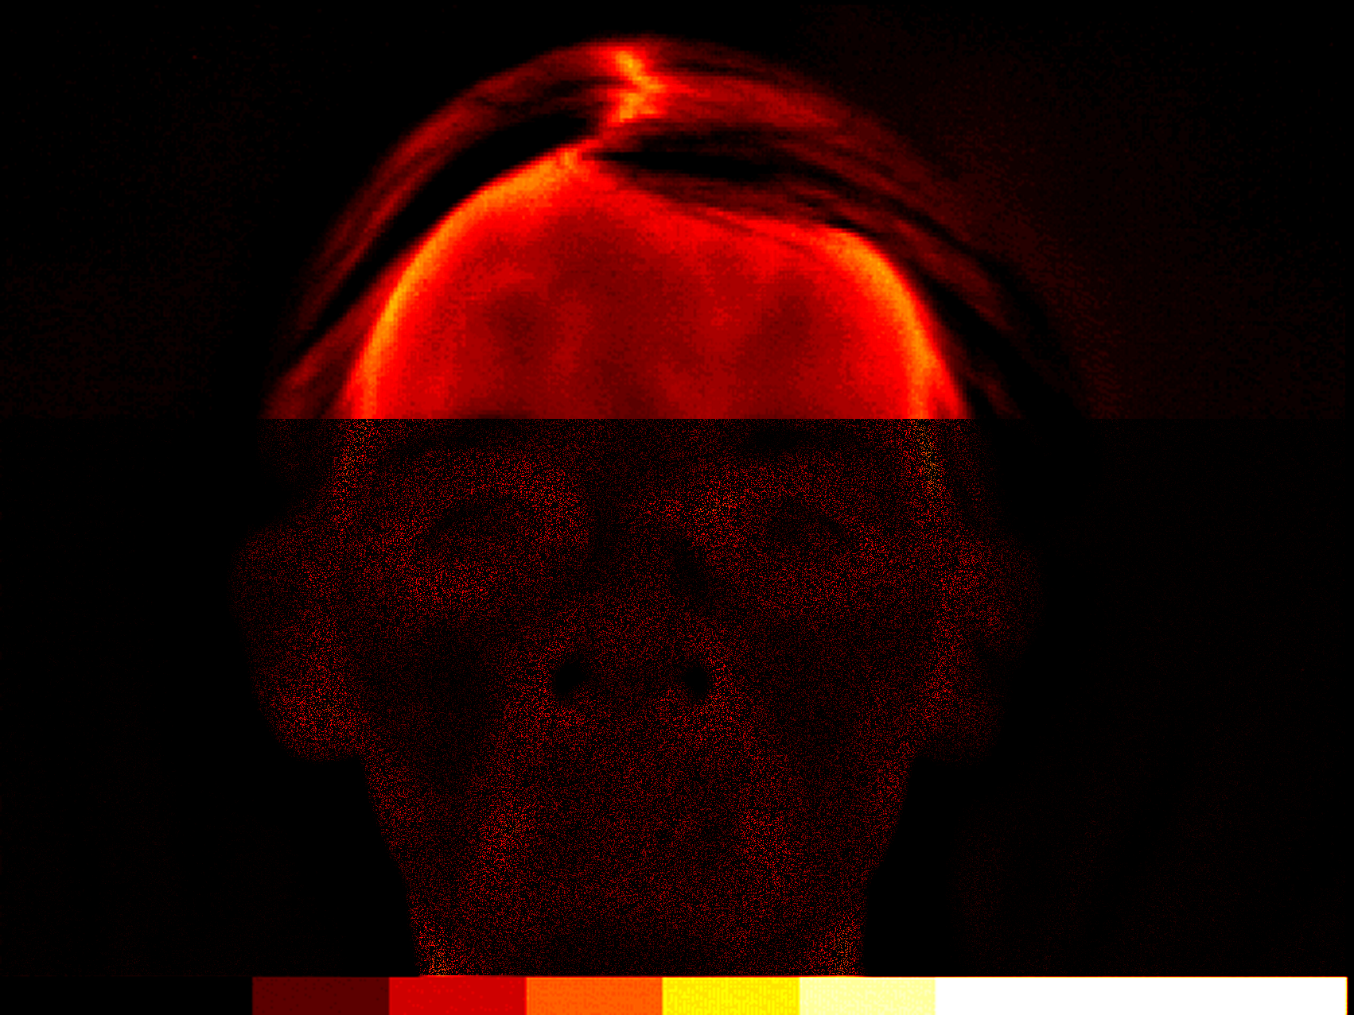

It is not unusual for these forehead infrared images to become progressively lighter over time. This generally correlates with symptom reduction and may indicate a general increase in normal prefrontal cortical activity.

Patient #37.
This 24 year old woman started and finished treatment prior to the installation of either of the infrared imaging systems, but is worth mentioning because of the urgency of the situation. She had a long standing history of severe migraines since early adolescence. The migraines were debilitating when they occurred but tended to be infrequent. They sometimes hit once a week, sometimes once a month, sometimes months between migraines. These were managed reasonably well with various abortive medications. Most recently she had been very successfully managing her migraines using oral Imitrex. Imitrex is the first of the new breed of drugs called “triptans”, and for many people has allowed them to live much more normal lives.
The problem is that this young woman found herself pregnant, and although sometimes migraines get better during pregnancy (Marcus, 1999), hers got worse. The triptan drugs are powerful vasoconstrictors, and have been shown in animal studies to have teratogenic effects (Tepper, 2001). She needed an alternate way to manage her migraines during pregnancy, that did not carry potential risks to the health of the unborn baby.
The migraines came under rapid control, reducing first in intensity and then frequency. (As previously noted, reduction in frequency is a difficult thing to measure because if the intensity is reduced sufficiently it is difficult to tell if a migraine actually happened or not). In any case, after 3 sessions over a period of 3 weeks, her migraines seemed to be greatly diminished or completely gone, depending on the criteria used for defining the headaches. 5 more sessions were completed just because it seemed like a good idea. There was some continued headache activity through the balance of her pregnancy but it was unclear whether or not they were migraines or just general pregnancy related mild to moderate headaches. They did not require medication for pain management.

Patient #49.
This 41 year old woman had been suffering from severe migraines for the previous 6 years. They were severe enough to require occasional trips to the local emergency room for injected narcotics. Prophylactic and abortive medications had been only somewhat useful. Frequency varied from 1 per month to almost daily.
This case is less clear than the others in terms of etiology. Her mother also had occasional migraines, but not with such a severe frequency or intensity. Correlated with the onset of her migraines was severe chronic psychological stress from both work and home. She slept very poorly in that she would toss and turn all night and wake exhausted. The sleep patterns would rise and fall with the amount of psychological stress she was experiencing, although it was not clear as to whether the sinusitis played a role as well. In addition, there were a variety of comorbid physical disorders that fall into the category of “migraine aggravators” rather than migraine causes. These included temporomandibular joint problems, chronic bilateral maxillary sinus infections, and some ill defined generalized health problems. The headaches correlated positively with her menstrual cycle in that one severe migraine was predictable premenstrually. Others could come at any time. Usually she woke with a mild dull headache that was qualitatively different from the migraine. The migraine was usually left sided and throbbing. The morning headache was more generalized and dull. In terms of etiology, this is a difficult diagnostic judgment call. While there was probably a genetic component, there were enough physical problems to possibly account for the headaches. Also, the relatively late onset of the migraines is a little suspicious for secondary rather than primary migraine.
Surprisingly, her response to pIR HEG was very rapid, although the rapid response did not hold for extended periods of time. The other physical and psychological stressors remained relatively constant, but her migraines got better between sessions. This suggested that these migraines were in fact primary rather than being caused by some other physical disorder, although the physical problems were clearly making management difficult.
She completed 11 pIR HEG sessions over a period of 6 months. The first 5 sessions were 1 per week. After that the sessions were spread farther apart. Each session had what appeared to be both abortive and prophylactic effects. If she came in with a migraine, she left either without it, or greatly diminished. Any migraine activity between sessions was greatly diminished in terms of intensity. After the first 5 visits, her life became too complex to continue except on an intermittent basis. She would still get approximately 7 days of improved migraine control from each session, but the headaches would still creep back to previous levels by the end of the 2nd or 3rd week. She still comes in for an occasional session, but on an irregular basis.
This case represents a very complex set of circumstances. It has been included here as an example of the potential complexity of working with migraine headaches, since they usually seem to be affected if not actually driven by life stressors. The pIR HEG sessions clearly helped her a great deal. However she also had been living under unbelievable levels of psychological and physical stress, so it is not likely that the migraines were going to disappear altogether. In cases like this, sometimes it seems worthwhile to continue weekly sessions for a long period of time, or switch to home training. However in her particular life situation, neither was a viable option.
It is likely that when her life circumstances straighten out and her physical problems start to become less intense, her migraines will also become less troublesome. When that happens, further pIR HEG sessions may bring her migraines under exceptionally smooth control.
Image #10 is a baseline from a recent scheduled session. She came in with a very bad migraine, localized to the right temporal region. In the image, that region can be seen to be relatively brighter and covering a relatively larger area than the left side. The “wings” on either side of her head are her hands holding her hair out of the picture. This was also unusual for her in that most of her migraines have been left sided.

IMAGE 10
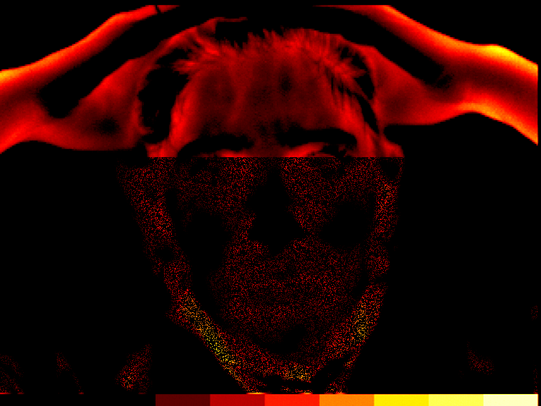

Image #11 was captured immediately after the session was completed. The headache was completely gone.

IMAGE 11
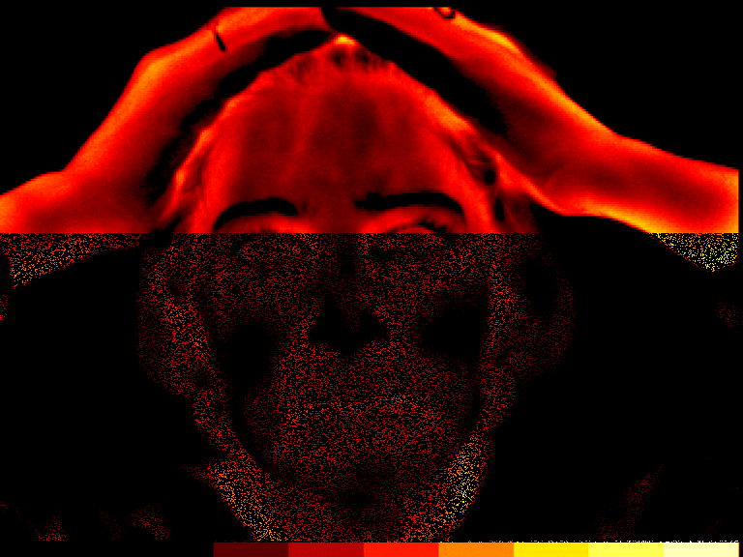

The thermal output from the forehead on this image shows less of a right/left difference, and the forehead is generally lighter in color, indicating increased overall prefrontal cortical activity. The same caveats apply in this situation as the previous two sets of images. These images correlate with migraine pain or lack of it. They may or may not represent the underlying physiological mechanism generating the pain. Regardless, the reliability of these images is very high. The utility of these images becomes greater when studied as specific patterns that are unique to each individual. Under those conditions, they become predictable and useful, especially as part of an ongoing differential diagnostic process.

RESULTS
The typical response pattern for all those who improved was to have the intensity level of the migraines change before anything else changed. The headaches, when they occurred were less intense. The point of “significant improvement” was defined as the point at which it had become difficult to identify headaches as “migraine”. From the standpoint of headache patterns, the focal location of the pain usually remained the same as the “migraines”, but the pain level was much less, sometimes becoming almost indiscernible.
Reduction in headache frequency typically came weeks or months after reduction in pain levels. This is an even more complex and unreliable measure than pain level because as pain levels drop it becomes more and more difficult to determine if a headache (migraine) actually happened. Detailed questioning has revealed that many people will continue to have very low intensity “events” that are probably actual migraines but have an intensity so low that it requires very careful data collection for identification as a migraine. Often they are not even identified as headaches. Sometimes the only way to identify them is by patterns of events. For example, if the person’s migraines typically triggered on a Friday after a long hard week, that person might continue to have very low intensity “events” at the time and day that they used to get a migraine headache. These are probably still migraine headaches, but they lack intensity. These “events” can be non pain events that present only as altered sensations. This observation may lend support to the hypothesis that the mechanism of action of the pIR HEG system on migraine headaches is through inhibition of the migraine generator. Functionally the migraines appear to become weaker. It may be that the frequency actually remains constant. Self reports are inadequate for this level of discrimination, and the infrared images are so sensitive to intensity that they don’t help much either.
The decision to terminate treatment was typically based on a variety of variables, most of them personal. Given the option of continuing sessions as long as needed, they were continued weekly until the headaches had stabilized to a comfortable point. Then the sessions were spread out progressively farther apart until a mutual agreement was reached to completely terminate. Personal preferences varied as to the degree of migraine management desired. Most were satisfied with relative freedom from debilitating headaches, relying to some extent on medication for the occasional very bad headache.
For those 61 individuals for whom pre/post infrared images were recorded, the following observations also apply:
- The strongest correlate of the impact of the session was a decrease in dark areas in the image rather than the total increase in lightness of the image. This is somewhat consistent with the “cold patch” observed by Swerdlow & Dieter (1991). However because of the age and technology of their infrared camera, their images are not directly comparable with either of the image data sets in this study.

TABLE 2
PATTERNS OF HEADACHE IMPROVEMENT
 | MALE | FEMALE | TOTAL
NUMBER OF SUBJECTS | 36 | 64 | 100
“SIGNIFICANT IMPROVEMENT” IN 6 SESSIONS OR LESS | 23 (64%) | 38 (59%) | 61 (61%)
ADDITIONAL SUBJECTS WITH “SIGNIFICANT IMPROVEMENT” IN 7 SESSIONS OR MORE | 5 (14%) | 6 (9%) | 11 (11%)
TOTAL IMPROVED | 28 (78%) | 44 (69%) | 72 (72%)
REGARDED THEMSELVES AS “COMPLETELY CURED” | 2 (6%) | 2 (3%) | 4 (4%)
DID NOT IMPROVE AT ALL | 8 (22%) | 20 (31%) | 28 (28%)
DROPPED OUT BEFORE 6 SESSIONS | 8 (22%) | 16 (25%) | 24 (24%)
TOTAL IMPROVED (OF THOSE SUBJECTS WHO DID NOT DROP OUT BEFORE 6 SESSIONS) | 28/28 (100%) | 44/48 (92%) | 72/76 (95%)

TABLE 3
VARIABLES ASSOCIATED WITH DROPPING OUT BEFORE 6 SESSIONS
 | MALE | FEMALE | TOTAL
FINANCIAL | 1 | 10 | 11
DRUG ADDICTION (MIGRAINE MEDICATION) | 1 | 3 | 4
PSYCHOLOGICAL REASONS | 6 | 5 | 11

For both males and females, the majority started to see signs of improvement in 6 sessions or less. Of the 36 males in this study, 23 improved enough in 6 sessions to consider themselves significantly improved. Of the 64 females, 38 improved enough in 6 sessions to consider themselves significantly improved. Most continued on for more sessions, terminating when it felt comfortable or when the financial or time inconvenience of coming to an appointment was greater than the inconvenience caused by the relatively minor headaches. The number of sessions does appear to have some predictive importance in that most who eventually achieved “significant improvement” showed signs of improvement by session #6.
A relatively smaller number of males (5) and females (6) took more than 6 sessions before they saw signs of improvement. The cutoff point of 6 sessions appears to have considerable predictive value in that if someone has not seen signs of improvement by session number 6, it is only somewhat likely that more sessions will help. For those who needed more sessions to see improvement, typically they needed much more. Some went as high as 20 or 30 sessions.

Other observations.
4 people regarded themselves as completely cured. Followup suggests that this may in fact be the case.
Not everyone improved. 8 of the males and 20 of the females did not improve at all. However, all of the males who did not improve, and 16 of the females who did not improve, had dropped out prior to 6 sessions. It is unknown if these would have converted into “significantly improved” had they continued.
An analysis of the patterns of reasons for dropping out, showed great variability and the reasons given may not have always been the real reasons. 1 male and 10 females dropped out for financial reasons. The reason for the extreme female/male ratio on this variable is unclear. The psychological reasons for dropping out were also quite variable and idiosyncratic. Some people were addicted to the migraine medications and did not or could not stop taking them. These drugs would often produce a once or twice daily rebound headache. Breaking the cycle required a total withdrawal from abortive medication, that these people were either unwilling or unable to accomplish.
The infrared images added a very useful measure for those for whom it was available. If a person came into the session with a headache, painful areas could usually be identified as high intensity areas on the images. Not everyone came to a session with a headache, but it happened often enough to gather some data. Typically the high intensity painful areas would reduce to a lower intensity by the end of the session, correlated with a reduced pain level. This was a very consistent finding.

Observations and impressions.
These are general subjective impressions from working directly with all of these patients using the pIR HEG process. Most people like the process, and learn it quickly, in spite of the fact that the high intensity cognitive “effort” combined with a very relaxed emotional state is an unfamiliar concept to almost everyone.
The reasons for change in migraine status remain unclear. It is likely that the mechanisms involve the inhibitory functions that are closely associated with the prefrontal cortex, but at this point that is hypothesis rather than proven fact.

CONCLUSIONS
The results of this study support the observations of other clinicians using the pIR HEG system with migraine patients. Migraine patients appear to improve strongly, and quickly, usually seeing positive effects within the first 6 sessions. In addition, the effects appear to be both prophylactic and abortive. Because the system is so new, long term data is not yet available. It must still be considered an experimental intervention.
More precise pre/post psychophysiological measures such as fMRI, QEEG and related imaging processes may eventually help to clarify the specific brain mechanisms activated by this process. As more data is gathered, it may even contribute meaningful information to ongoing attempts to clarify the basic pathophysiological mechanisms associated with migraine headaches.

REFERENCES
Bednarczyk, E., Remier, B., Weikert, C., Nelson, A., Reed, R. (1998). Global blood flow, blood volume, and oxygen metabolism in patients with migraine headache. Neurology, 50 (6), 1736-1740.
Breslau, N. (1998) Psychiatric comorbidity in migraine. Cephalalgia, 18 (22), 56-61.
Carmen, J. A. (2002). Passive Infrared Hemoencephalography, 4 Years and 100 migraines later. Presented at 2002 Society for Neuronal Regulation conference, Scottsdale, AZ.
Carmen, J. A. (2004). Passive infrared hemoencephalography: Four years and 100 migraines. Journal of Neurotherapy, 8 (3), 23-51.
Diamond, S. (1994). Head Pain: diagnosis and management. Clinical Symposia, 46 (3), 2-34.
Fraden, J (1996). Handbook of modern sensors, physics, designs, and applications. New York: Springer-Verlag New York, Inc.
Goadsby, P. (2001). Pathophysiology of headache, 57-72, in Silberstein, S., Lipton, R., and Dalessio, D. eds Wolff’s Headache and other Head Pain, 7th edition. New York: Oxford University Press, Inc.
Goldberg, E. (2001). The executive brain. New York: Oxford University Press, Inc.
Kaplan, H. (1999). Practical applications of infrared thermal sensing and imaging equipment. Bellingham, Washington: International Society for Optical Engineering.
Kiyaikin, E. A. (2002) Brain temperature fluctuation: a reflection of functional neural activation. European Journal of Neuroscience, 16 (1), 164-168.
Lipton, R. B., Stewart, W. F., Diamond, S., Diamond, M., Reed, M. L. (2001). Prevalence and burden of migraine in the United States: Results from American Migraine Study II. Headache. 41 (7), 646-657.
Madhu, S. (1985). Electronic circuits and systems. Indianapolis: Howard W. Sams Co., Inc.
Marcus, D. (1999), Special considerations in the management of headache in women. Headache Quarterly, 10 (1), 37-43.
Mitsikostas, D., Thomas, A., (1999) Comorbidity of headache and depressive disorders. Cephalalgia, 18 (22), 22-25.
Moskowitz, M. (1998), Migraine and stroke - a review of cerebral blood flow. Cephalalgia, 18 (22), 22-25.
Pinker, S. (1997). How the mind works. New York: W. W. Norton & Company, Inc.
Pribram, K & McGuinness, D. Arousal, activation, and effort in control of attention. Psychological Review, 1975, 82 (2), 116-149.
Sacks, O., (1992). Migraine. England: University of California Press.
Shevelev, I.A., (1992) Temperature topography of the brain cortex: Thermoencephaloscopy. Brain Topography, 6 (2), 77-85.
Shevelev, I.A., (1998) Functional imaging of the brain by infrared radiation (thermoencephaloscopy) Progress in Neurobiology. 56 (3), 269-305.
Swerdlow, B. & Dieter, J. (1991) The value of medical thermography for the diagnosis of chronic headache. Headache Quarterly, 2 (2), 96-104.
Tepper, S.J. (2001), Safety and rational use of the triptans. Medical Clinics of North America. 85 (4), 959-970.
Toomim, H., Carmen, J. (1999). Hemoencephalography (HEG). Biofeedback, 27 (4), 10-14, 27.
Toomim, H. (12/2002) Personal communication.

